**GNA**

**UNIVERSITY**

**BCS 101**

C Language

(Problem Solving)

Assignment

Submitted for partial fulfilment of requirement for award of degree

Of

Bachelor of technology

In

Computer science and engineering

Batch 2019 – 2023

Of

Faculty of computational science

Submitted to: Submitted by:

Mrs Monica Sharma Nageshwar Pandey

Designation: Assistant Professor GU-2019-3130

Department: FCS B.TECH CSE 3rd sem

1. Write a program which inputs a positive integer *n* and outputs 2 raised to the power of *n*.

Program:

#include <stdio.h>

int main(void) {

int no, result;

result= 1;

printf("PLZ inter any positive no::");

scanf("%d",&no);

for(int i=1;i<=no;i++){

result = result*2;

}

printf("Result::%d",result);

}

**Output:**

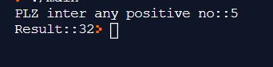

1. Write a Program in C to convert the temperature from degree Celsius to DegreeFahrenheit scale

#include <stdio.h>

int main()

{

float celsius, fahrenheit;

printf("Enter temperature in Celsius: ");

scanf("%f", &celsius);

fahrenheit = (celsius * 9 / 5) + 32;

printf("%.2f Celsius = %.2f Fahrenheit", celsius, fahrenheit);

return 0;

}

**Output**

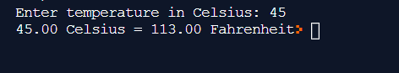

1. Write a program in C to calculate the circumference of the circle whose radius is given.

#include <stdio.h>

int main()

{

int circle_radius;

float PI_VALUE=3.14, circle_area, circle_circumf;

printf("\nEnter radius of circle: ");

scanf("%d",&circle_radius);

circle_area = PI_VALUE * circle_radius * circle_radius;

printf("\nArea of circle is: %f",circle_area);

circle_circumf = 2 * PI_VALUE * circle_radius;

printf("\nCircumference of circle is: %f",circle_circumf);

return(0);

}

**Output**

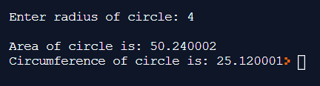

1. Write a program in C to swap the values of variables Using third variable.

#include <stdio.h>

int main(void)

{

int a, b, temp;

printf("Enter two numbers a and b ");

scanf("%d %d", &a, &b);

temp = a;

a = b;

b = temp;

printf("\n After swapping \na = %d\nb = %d\n", a, b);

return 0;

}

**Output**

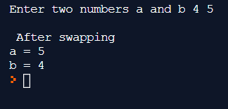

1. Write a program in C to swap the values of variables without Using third variable.

#include <stdio.h>

int main()

{

  int x = 10, y = 5;

printf("Numbers before swapping::%d %d",x,y);

  x = x + y;

  y = x - y;

  x = x - y;

  printf("\nNumbers after swapping::%d %d",x,y);

}

**Output**

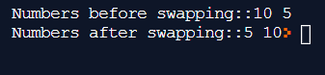

1. Write a program in C to print 1 if entered number is between 1-100 Otherwise 0 using AND operator.

#include<stdio.h>

int main(){

int no;

printf("plz Enter a number::");

scanf("%d",&no);

if(no>1 && no<100){

printf("1");

}

else

printf("0");

}



1. Write a program which inputs three numbers and outputs the message Sorted if the numbers are in ascending order, and outputs Not sorted otherwise.

#include<stdio.h>

int main(){

int no1, no2,no3;

printf("plz Enter 3 numbers::");

scanf("%d%d%d",&no1,&no2,&no3);

if(no1<no2<no3){

printf("Number is sorted in ascending order");

}

else

printf("Number is not sorted");

}

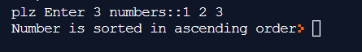

1. Write a program that reverses any n-digit number entered through the keyboard and tells whether the number is palindrome or not.

#include <stdio.h>

int main() {

int n, reversedN = 0, remainder, originalN;

printf("Enter an integer: ");

scanf("%d", &n);

originalN = n;

while (n != 0) {

remainder = n % 10;

reversedN = reversedN * 10 + remainder;

n /= 10;

}

if (originalN == reversedN)

printf("%d is a palindrome.", originalN);

else

printf("%d is not a palindrome.", originalN);

return 0;

}

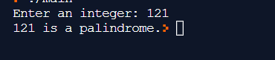

1. Write a program to check whether a triangle is valid or not, when the three angles of the triangle are entered through the keyboard. A triangle is valid if the sum of all the three angles is equal to 180 degrees.

#include<stdio.h>

int main()

{

float a,b,c,sum;

printf("enter three angles a,b,c");

scanf("%f%f%f",&a,&b,&c);

sum=a+b+c;

if(sum==180)

printf("triangle is valid");

else

printf("triangle is not valid");

}



1. Given the length and breadth of a rectangle, write a program to find whether the area of the rectangle is greater than its perimeter. For example, the area of the rectangle with length = 5 and breadth = 4 is greater than its perimeter.

#include<stdio.h>

int main()

{

  int length, breadth, perimeter, area;

  printf("Enter length and breadth: ");

  scanf("%d%d", &length, &breadth);

  area = length*breadth;

  perimeter = 2 * (length + breadth);

  printf("Area is : %d",area);

  printf("\nPerimeter is : %d",perimeter);

  if (area>perimeter)

    printf("\nArea is greater than perimeter");

  else if (area<perimeter)

    printf("Area is lesser than perimeter");

  else

    printf("Area and perimeter are equal");

  return 0;

}

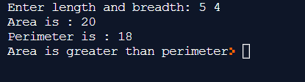

1. Any character is entered through the keyboard, write a program to determine whether the character entered is a capital letter, a small case letter, a digit or a special symbol. The following table shows the range of ASCII values for various characters.

|  |  |
| --- | --- |
| **Characters** | **ASCII Values** |
| A-Z | 65-90 |
| a-z | 97-122 |
| 0-9 | 48-57 |
| Special symbols | 0-47, 58-64, 91-96, 123-127 |

#include<stdio.h>

int main ()

{

  char ch;

  printf("Enter any character:");

  scanf("%c",&ch);

  if (ch>=65 && ch<=90)

      printf("Character is a capital letter");

  else if (ch>=97 && ch<=122)

    printf("Character is a small letter");

  else if (ch>=48 && ch<=57)

      printf("Character is a digit");

  else if ((ch>0 && ch<=47)||(ch>=58 && ch<=64)||

(ch>=91 && ch<=96)||(ch>=123 && ch<=127))

      printf("Character is a special symbol");

  return 0;

}

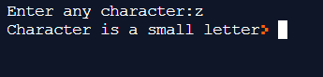

1. An Insurance company follows following rules to calculate premium.

(1) If a person’s health is excellent and the person is between 25 and 35 years of age and lives in a city and is a male then the premium is Rs. 4 per thousand and his policy amount cannot exceed Rs. 2 lakhs.

(2) If a person satisfies all the above conditions except that the sex is female then the premium is Rs. 3 per thousand and her policy amount cannot exceed Rs. 1 lakh.

(3) If a person’s health is poor and the person is between 25 and 35 years of age and lives in a village and is a male then the premium is Rs. 6 per thousand and his policy cannot exceed Rs. 10,000.

(4) In all other cases the person is not insured.

Write a program to output whether the person should be insured or not, his/her premium rate and maximum amount for which he/she can be insured.

#include<stdio.h>

int main()

{

char h,l,g;

int a;

printf("Enter Heath e For Excellent And p For Poor ");

scanf("%c",&h);

printf("Enter Location c For City And v For Village ");

scanf("\n%c",&l);

printf("Enter Gender m For Male And f For Female ");

scanf("\n%c",&g);

printf("Enter Age ");

scanf("\n%d",&a);

if((h=='e')&&(l=='c')&&(g=='m')&&(a>=25||a<=35))

printf("\nThe Premium Is Rs.4 Per Thousand And His Policy Cannot Exceed Rs.2 Lakhs");

else if((h=='e')&&(l=='c')&&(g=='f')&&(a>=25||a<=35))

printf("\nThe Premium Is Rs.3 Per Thousand And Her Policy Cannot Exceed Rs.1 Lakhs");

else if((h=='p')&&(l=='v')&&(g=='m')&&(a>=25||a<=35))

printf("\nThe Premium Is Rs.6 Per Thousand And Cannot Exceed Rs. 10,000");

else

printf("\n not Insured");

}

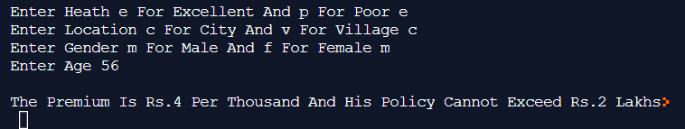

1. The policy followed by a company to process customer orders is given by the following rules:

(a) If a customer order is less than or equal to that in stock and has credit is OK, supply has requirement.

(b) If has credit is not OK do not supply. Send him intimation.

(c) If has credit is Ok but the item in stock is less than has order, supply what is in stock. Intimate to him data the balance will be shipped.

Write a C program to implement the company policy.

#include<stdio.h>

int main()

{

int products, temp;

char cr;

printf("Enter the customer order :- ");

scanf("%d",&products);

printf("Is his credit OK ?(y/n)\n");

scanf("%s",&cr);

if(products<=100 && cr=='y' ){

printf("\ngood party.");

printf(" product is supplied to this customer");

}

else if(products>100 && cr=='y')

printf("\ngood party But sorry we have not such amount of product so 100 products will be supplied now.");

else

printf("\nSorry boss! First clear your credits, until we cant supply you any more.");

}

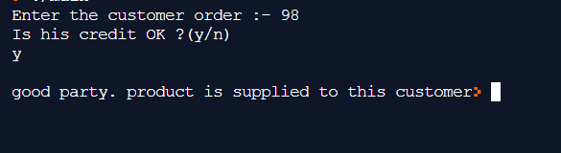

1. Using conditional operators determine:

(1) Whether the character entered through the keyboard is a lower case alphabet or not.

(2) Whether a character entered through the keyboard is a special symbol or not.

#include<stdio.h>

int main()

{

char charac;

printf("Enter the character to be detected:");

scanf("%c", &charac);

((charac>=97) && (charac<=122))?(printf("\nLower Case")):(printf("\nNot a Lower Case character"));

(((charac>=0) && (charac<=47)) || ((charac>=58) && (charac<=64))|| ((charac>=91) && (charac<=96))|| ((charac>=123) && (charac<=127)))? (printf("\nSpecial Symbol")):(printf("\nNot a Special Symbol"));

}

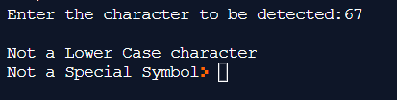

1. Write a program in C to find the greatest of three numbers using conditional operators.

#include <stdio.h>

int main()

{

int n1 = 5, n2 = 10, n3 = 15, max;

max = (n1 > n2) ? (n1 > n3 ? n1 : n3) : (n2 > n3 ? n2 : n3);

printf("Largest number among %d, %d and %d is %d.", n1, n2, n3, max);

return 0;

}

Output:



1. Write a program that calculates the factorial of any given number.

#include <stdio.h>

int main() {

int n, i;

unsigned long long fact = 1;

printf("Enter an integer: ");

scanf("%d", &n);

if (n < 0)

printf("Error! Factorial of a negative number doesn't exist.");

else {

for (i = 1; i <= n; ++i) {

fact *= i;

}

printf("Factorial of %d = %llu", n, fact);

}

return 0;

}

Output:



1. Two numbers are entered through the keyboard. Write a program to find the value of one number raised to the power of another.

#include<stdio.h>

#include<math.h>

int main()

{

int a, b, c;

printf("Enter the value of a: ");

scanf("%d", &a);

printf("Enter the value of b: ");

scanf("%d", &b);

c = pow(a,b);

printf("%d raised to the power %d: %d",a,b,c);

}

**Output:**

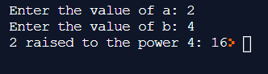

1. Write a program in C to display the months of an year using switch statement.

#include<stdio.h>

int main() {

int a;

printf("Enter no::");

scanf("%d", & a);

switch (a) {

case 1:

printf("January");

break;

case 2:

printf("February");

break;

case 3:

printf("March");

break;

case 4:

printf("April");

break;

case 5:

printf("May");

break;

case 6:

printf("June");

break;

case 7:

printf("July");

break;

case 8:

printf("August");

break;

case 9:

printf("September");

break;

case 10:

printf("October");

break;

case 11:

printf("November");

break;

case 12:

printf("December");

break;

default:

printf("Invalid month");

}

return 0;

}

**Output:**

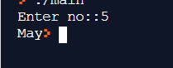

1. Write a program in C to check the entered alphabet for vowel or consonant.

#include <stdio.h>

int main() {

char c;

int lowercase, uppercase;

printf("Enter an alphabet: ");

scanf("%c", &c);

lowercase = (c == 'a' || c == 'e' || c == 'i' || c == 'o' || c == 'u');

uppercase = (c == 'A' || c == 'E' || c == 'I' || c == 'O' || c == 'U');

if (lowercase || uppercase)

printf("%c is a vowel.", c);

else

printf("%c is a consonant.", c);

return 0;

}

**OUTPUT:**

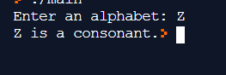

1. Write a program to print all the ASCII values and their equivalent characters using a while loop. The ASCII values vary from 0 to 255.

#include<stdio.h>

int main(){

int i,no;

for(i=0;i<=255;i++){

printf("%d Ascii value %c",i,i);

printf("\n");

}

return 0;

}

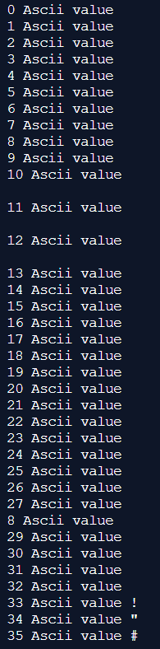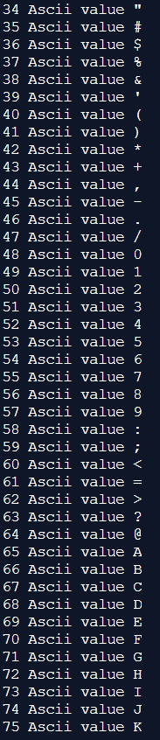 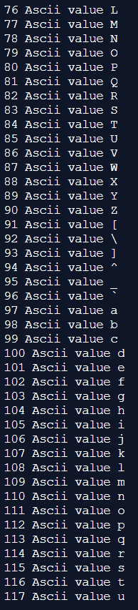

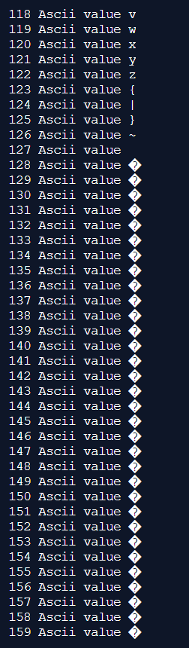 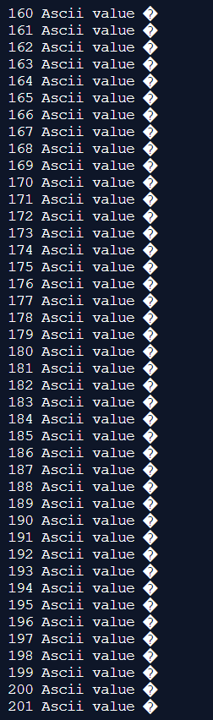 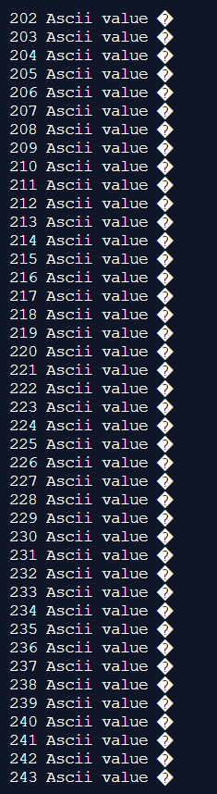 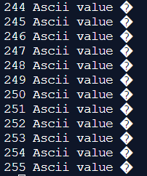

1. Write a program to print out all Armstrong numbers between 1 and 500. If sum of cubes of each digit of the number is equal to the number itself, then the number is called an Armstrong number. For example, 153 = ( 1 * 1 * 1 ) + ( 5 * 5 * 5 ) + ( 3 * 3 * 3 )

#include<stdio.h>

int main()

{

int num, count = 1, rem, sum;

while(count <= 500)

{

num = count;

sum = 0;

while(num)

{

rem = num % 10;

sum = sum + (rem * rem * rem);

num = num / 10;

}

if(count == sum)

{

printf("%d is a Armstrong number\n", count);

}

count++;

}

return 0;

}

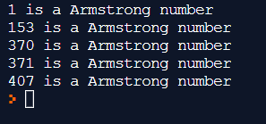

1. Write a program to find the octal equivalent of the entered number.

#include <stdio.h>

int main()

{

long long decimal, tempDecimal, octal;

int i, rem, place = 1;

octal = 0;

printf("Enter any decimal number: ");

scanf("%lld", &decimal);

tempDecimal = decimal;

while(tempDecimal > 0)

{

rem = tempDecimal % 8;

octal = (rem * place) + octal;

tempDecimal /= 8;

place *= 10;

}

printf("\nDecimal number = %lld\n", decimal);

printf("Octal number = %lld", octal);

return 0;

}

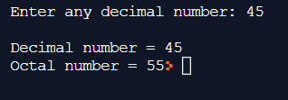

1. Write a program to print prime numbers from 1 to 250

#include<stdio.h>

int main()

{

int n,i,fact,j;

printf("Enter the Number");

scanf("%d",&n);

printf("Prime Numbers are: \n");

for(i=1; i<=n; i++)

{

fact=0;

for(j=1; j<=n; j++)

{

if(i%j==0)

fact++;

}

if(fact==2)

printf("%d " ,i);

}

return 0;

}

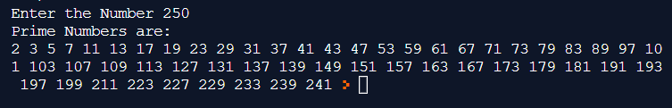

1. Write a program to produce the following output:

A B C D E F G F E D C B A

A B C D E F F E D C B A

A B C D E E D C B A

A B C D D C B A

A B C C B A

A B B A

A A

#include<stdio.h>

int main()

{

int i,j,k,l,m;

for(i=0;i<=6;i++)

{

for(k=65;k<=71-i;k++)

printf("%c",k);

for(j=1;j<=i*2-1;j++)

printf(" ");

for(l=71-i;l>=65;l--)

if(l!=71)

printf("%c",l);

printf("\n");

}

return 0;

}

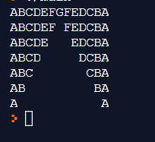

1. Write a program to produce the following pascals triangle:

1

1 1

1 2 1

1 3 3 1

1. 4 6 4 1

#include <stdio.h>

long factorial(int);

int main()

{

int i, n, c;

printf("Enter the number of rows you wish to see in pascal triangle\n");

scanf("%d",&n);

for (i = 0; i < n; i++)

{

for (c = 0; c <= (n - i - 2); c++)

printf(" ");

for (c = 0 ; c <= i; c++)

printf("%ld ",factorial(i)/(factorial(c)*factorial(i-c)));

printf("\n");

}

return 0;

}

long factorial(int n)

{

int c;

long result = 1;

for (c = 1; c <= n; c++)

result = result*c;

return result;

}

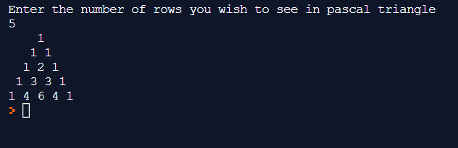

1. Write a program in C to show the table of the entered number.

#include <stdio.h>

int main() {

int n, i;

printf("Enter an integer: ");

scanf("%d", &n);

for (i = 1; i <= 10; ++i) {

printf("%d * %d = %d \n", n, i, n * i);

}

return 0;

}

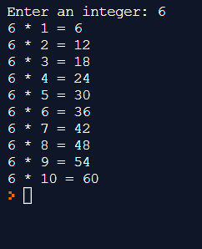

1. Write a Program in C to print even numbers from 1 to N using for loop.

#include <stdio.h>

int main()

{

int i, n;

printf("Print all even numbers till: ");

scanf("%d", &n);

printf("All even numbers from 1 to %d are: \n", n);

i=1;

while(i<=n)

{

if(i%2==0)

{

printf("%d\t", i);

}

i++;

}

return 0;

}

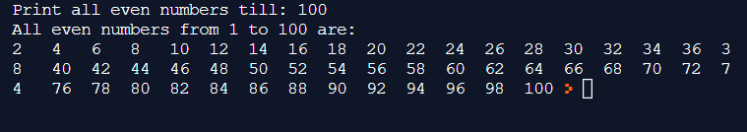

1. Write a Program in C to print the Pattern upto n lines as entered by the user

*

* *

* * *

* * * *

#include <stdio.h>

int main()

{

int i,j,rows;

printf("Input number of rows : ");

scanf("%d",&rows);

for(i=1;i<=rows;i++)

{

  for(j=1;j<=i;j++)

   printf("*");

  printf("\n");

}

}

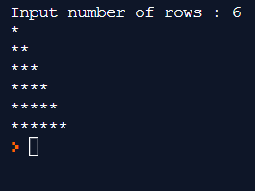

1. Write a Program in C to Print the pattern upto n lines as entered by the user

*

* *

* * *

* * * *

#include <stdio.h>

int main()

{

int i, j, rows;

printf("Enter number of rows : ");

scanf("%d", &rows);

for(i=1; i<=rows; i++)

{

for(j=i; j<rows; j++)

{

printf(" ");

}

for(j=1; j<=(2*i-1); j++)

{

printf("*");

}

printf("\n");

}

return 0;

}

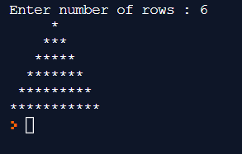

1. Write a program in C to print the pattern.

***** *****

**** ****

*** ***

** **

* *

#include<stdio.h>

int main()

{

int i,j,k,l,m;

for(i=0;i<=6;i++)

{

for(k=65;k<=71-i;k++)

printf("*",k);

for(j=1;j<=i*2-1;j++)

printf(" ");

for(l=71-i;l>=65;l--)

if(l!=71)

printf("*");

printf("\n");

}

return 0;

}

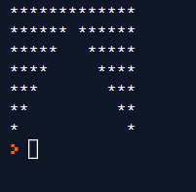

1. Write a program to find the grace marks for a student using switch. The user should enter the class obtained by the student and the number of subjects he has failed in.

− If the student gets first class and the number of subjects he failed in is greater than 3, then he does not get any grace. If the number of subjects he failed in is less than or equal to 3 then the grace is of 5 marks per subject.

− If the student gets second class and the number of subjects he failed in is greater than 2, then he does not get any grace. If the number of subjects he failed in is less than or equal to 2 then the grace is of 4 marks per subject.

− If the student gets third class and the number of subjects he failed in is greater than 1, then he does not get any grace. If the number of subjects he failed in is equal to 1 then the grace is of 5 marks per subject

#include<stdio.h>

int main()

{

int clss, nos_fail, grace;

printf("Enter class obtained by student and number of subjects he failed in ");

scanf("%d%d",&clss,&nos_fail);

switch(clss)

{

case 1:

switch(nos_fail)

{

case 1:

case 2:

case 3:

grace=5;

break;

default:3

grace=0;

break;

}

break;

case 2:

switch(nos_fail)

{

case 1:

case 2:

grace=4;

break;

default:

grace=0;

break;

}

break;

case 3:

switch(nos_fail)

{

case 1:

grace=5;

break;

default:

grace=0;

break;

}

break;

}

printf("\nStudent will get %d grace marks per subject",grace);

return 0;

}

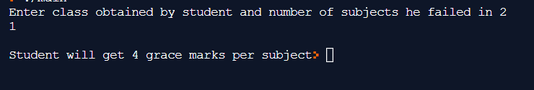

1. Write a program to add and subtract two matrices.

#include <stdio.h>

void trace(int arr[][10], int m, int n);

int main()

{

int array1[10][10], array2[10][10], arraysum[10][10],

arraydiff[10][10];

int i, j, m, n, option;

printf("Enter the order of the matrix array1 and array2 \n");

scanf("%d %d", &m, &n);

printf("Enter the elements of matrix array1 \n");

for (i = 0; i < m; i++)

{

for (j = 0; j < n; j++)

{

scanf("%d", &array1[i][j]);

}

}

printf("MATRIX array1 is \n");

for (i = 0; i < m; i++)

{

for (j = 0; j < n; j++)

{

printf("%3d", array1[i][j]);

}

printf("\n");

}

printf("Enter the elements of matrix array2 \n");

for (i = 0; i < m; i++)

{

for (j = 0; j < n; j++)

{

scanf("%d", &array2[i][j]);

}

}

printf("MATRIX array2 is \n");

for (i = 0; i < m; i++)

{

for (j = 0; j < n; j++)

{

printf("%3d", array2[i][j]);

}

printf("\n");

}

printf("Enter your option: 1 for Addition and 2 for Subtraction \n");

scanf("%d", &option);

switch (option)

{

case 1:

for (i = 0; i < m; i++)

{

for (j = 0; j < n; j++)

{

arraysum[i][j] = array1[i][j] + array2[i][j];

}

}

printf("Sum matrix is \n");

for (i = 0; i < m; i++)

{

for (j = 0; j < n; j++)

{

printf("%3d", arraysum[i][j]) ;

}

printf("\n");

}

break;

case 2:

for (i = 0; i < m; i++)

{

for (j = 0; j < n; j++)

{

arraydiff[i][j] = array1[i][j] - array2[i][j];

}

}

printf("Difference matrix is \n");

for (i = 0; i < m; i++)

{

for (j = 0; j < n; j++)

{

printf("%3d", arraydiff[i][j]) ;

}

printf("\n");

}

break;

}

}

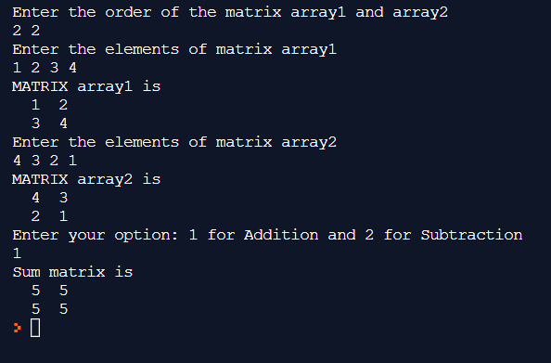

1. Write a program to multiply two matrices.

#include <stdio.h>

void enterData(int first[][10], int second[][10], int r1, int c1, int r2, int c2);

void multiplyMatrices(int first[][10], int second[][10], int multResult[][10], int r1, int c1, int r2, int c2);

void display(int mult[][10], int r1, int c2);

int main() {

int first[10][10], second[10][10], mult[10][10], r1, c1, r2, c2;

printf("Enter rows and column for the first matrix: ");

scanf("%d %d", &r1, &c1);

printf("Enter rows and column for the second matrix: ");

scanf("%d %d", &r2, &c2);

while (c1 != r2) {

printf("Error! Enter rows and columns again.\n");

printf("Enter rows and columns for the first matrix: ");

scanf("%d%d", &r1, &c1);

printf("Enter rows and columns for the second matrix: ");

scanf("%d%d", &r2, &c2);

}

enterData(first, second, r1, c1, r2, c2);

multiplyMatrices(first, second, mult, r1, c1, r2, c2);

display(mult, r1, c2);

return 0;

}

void enterData(int first[][10], int second[][10], int r1, int c1, int r2, int c2) {

printf("\nEnter elements of matrix 1:\n");

for (int i = 0; i < r1; ++i) {

for (int j = 0; j < c1; ++j) {

printf("Enter a%d%d: ", i + 1, j + 1);

scanf("%d", &first[i][j]);

}

}

printf("\nEnter elements of matrix 2:\n");

for (int i = 0; i < r2; ++i) {

for (int j = 0; j < c2; ++j) {

printf("Enter b%d%d: ", i + 1, j + 1);

scanf("%d", &second[i][j]);

}

}

}

void multiplyMatrices(int first[][10], int second[][10], int mult[][10], int r1, int c1, int r2, int c2) {

for (int i = 0; i < r1; ++i) {

for (int j = 0; j < c2; ++j) {

mult[i][j] = 0;

}

}

for (int i = 0; i < r1; ++i) {

for (int j = 0; j < c2; ++j) {

for (int k = 0; k < c1; ++k) {

mult[i][j] += first[i][k] * second[k][j];

} } }

void display(int mult[][10], int r1, int c2) {

printf("\nOutput Matrix:\n");

for (int i = 0; i < r1; ++i) {

for (int j = 0; j < c2; ++j) {

printf("%d ", mult[i][j]);

if (j == c2 - 1)

printf("\n");

} }}

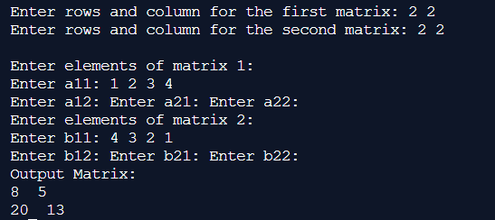

1. Write a program to transpose a matrix

#include <stdio.h>

int main() {

int a[10][10], transpose[10][10], r, c, i, j;

printf("Enter rows and columns: ");

scanf("%d %d", &r, &c);

printf("\nEnter matrix elements:\n");

for (i = 0; i < r; ++i)

for (j = 0; j < c; ++j) {

printf("Enter element a%d%d: ", i + 1, j + 1);

scanf("%d", &a[i][j]);

}

printf("\nEntered matrix: \n");

for (i = 0; i < r; ++i)

for (j = 0; j < c; ++j) {

printf("%d ", a[i][j]);

if (j == c - 1)

printf("\n");

}

for (i = 0; i < r; ++i)

for (j = 0; j < c; ++j) {

transpose[j][i] = a[i][j];

}

printf("\nTranspose of the matrix:\n");

for (i = 0; i < c; ++i)

for (j = 0; j < r; ++j) {

printf("%d ", transpose[i][j]);

if (j == r - 1)

printf("\n"); } return 0;}

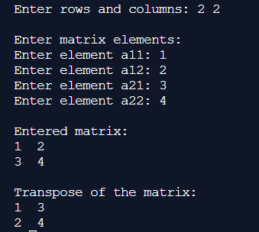

1. Write a program to inputs users name and displays it back to the user.

#include<stdio.h>

int main(){

char name[20];

printf("Enter your name::");

scanf("%s",&name);

printf("Your Entered name is::");

printf("%s",name);

return 0;

}

